***Hempstead Commerce and Civic Association***

***Meeting Minutes***

**January 18, 2022**

**Call to Order**

President Cheryl Hardwick called to order the monthly meeting of the Hempstead Commerce and Civic Association at 6:20 P.M. on Tuesday, January 18, 2022, at the Hempstead Recreation Center. Board Members, Barbara Bezub, Rick Castello, Cheryl Hardwick, Megan Avery Kenneth Pilcher, and Katherine Ward were present. Melissa Hegemeyer attended remotely.

**Invocation and Pledge of Allegiance**

Invocation was offered by Board Member Rick Castillo.

Pledge of allegiance was said by all members present.

**President Cheryl Hardwick welcomed all new members and guests.**

**Minutes**

Approval of December minutes – A motion was made by Board Member Kenneth Pilcher and seconded by Board Member Rick Castillo to approve the minutes. A vote was taken, and the motion carried.

**Treasurer’s Report**

The treasurer’s report was given by Treasurer Barbara Bezub. The current bank balance is $44,41629. A motion was made by Board Member Katherine Ward and seconded by Board Member Kenneth Pilcher to approve the report. A vote was taken, and the motion carried.

**Valentines Social**

Secretary, Megan Avery discussed HCCA’s Valentine “we heart Hempstead” business social and happy hour will be held Thursday, February 10th, 2022, from 5:30 to 7:30 P.M. located at Full Plate, 2105 13th St Hempstead, TX 77445. Light appetizers and drinks will be served. We ask that this be an adult only social hour. This is our first public social networking event for 2022.

**Recognize New Business in Hempstead**

The HCCA recognized the following new businesses in Hempstead:

Grit-N-Grace / Terry Kolenovsky - Located at 745 12th St, in Hempstead. This is a boutique styled shop that has home interior, jewelry, and antique furniture.

Ayala’s Boutique / Ellie Ayala - Located at 825 12th St in Hempstead. This is boutique styled apparel and clothing shop.

Tracy Tidwell spoke and mentioned her Ladies retreats and Christian Ministry for grades 9th-12th.

Board Member Kenneth Pilcher spoke about a new pest control business in town. Ram Pest Control Management 936-333-4410

Dustin Standley mentioned that the Tegeler Plaza has been leased by a fence company, a steel shop, and new door company.

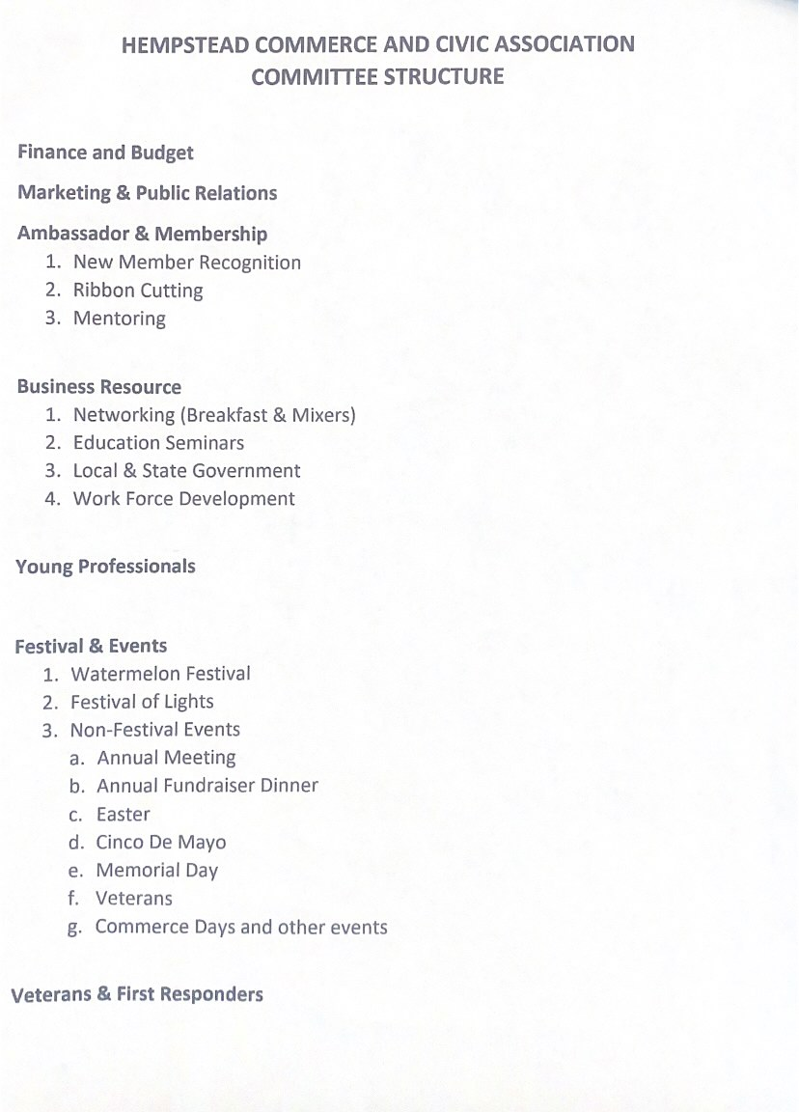

**HCCA Committee Structure**

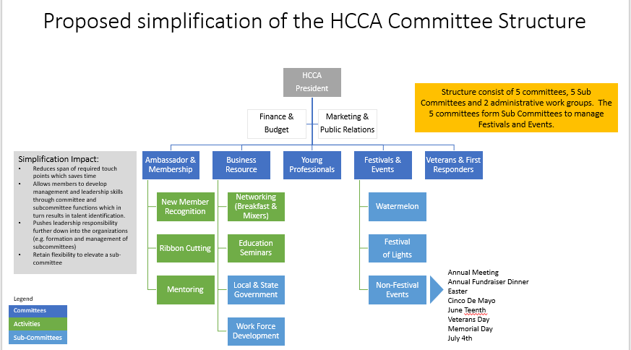

**Old Business**

We received a thank you note from focusing families thanking us for the kind donation to their organization.

The HCCA bylaws and membership packages have been approved by all board members at our last executive board meeting.

**New Business**

Lesha Roberts spoke and is running for the GOP Waller County Chair, she is a part of the Waller County Patriots.

Denise Maddox spoke and is running for the Waller County Democratic Chair.

Board member Kenneth pilcher spoke about partnering with Waller County Economic Development and cost sharing with Design at Work, which is the HCCA’s marketing agency. He also discussed HCCA committee structures.

**Upcoming Local Events**

President, Cheryl Hardwick went over upcoming local events as follows:

January Blow-Out Sale – House of Help, clothes, and toys, buy one, get one free with the same value or less. Hours are Tuesday thru Saturday 10:00 A.M. to 3:00 P.M.

Thursday, January 20, 2022, and Thursday, January 25, 2022 – House of Help Thrift Shop will be giving away free coats to kids. Location is 926 6th Street, Hempstead.

Friday, January 21, 2022 – Catholic Daughters Annual Fundraiser – 5 to 7:00 P.M. at the Knights of Columbus Hall. Chicken fried steak dinner for a cost of $15.00. Dine in or take out.

Saturday, January 22, 2022 – Hempstead Little League Sign up at the Hempstead City Park from 9:00 A.M. to 12:00 P.M.

Saturday, January 29, 2022 – Knights of Columbus Casino Night/Mardi Gras – 6 to 7:30 P.M. a steak dinner is served and Casino games from 7 to 10:00 P.M. Admission is $30.00 per person or $50.00 per couple.

Tuesday, February 1, 2022 – Texas Master Gardeners will be having a training program hosted by the Waller County Master Gardeners. The training runs from February 1 to March 1, 2022, meeting every Tuesday and Thursday from 9 to 11:00 A.M. and 1:00 to 4:00 P.M.

Friday, February 4, 2022 – Houston Livestock Show and Rodeo Houston Metro Go Texan Committee for Waller County – Back in the Saddle Again Rodeo Kick-Off for 2022. Tables can be purchased or individual tickets. Ticket includes dinner, drinks, live and silent auction, desert dash, and live entertainment. Event will be held at the 2K Reserve, 26260 Nelson Road, Hempstead from 6 to 11:00 P.M. $80,000.00 in scholarships are awarded to Waller County area seniors in May.

Saturday, February 19, 2022 – Hempstead Little League 6th Annual Crawfish Boil Fundraiser. Located at the Knights of Columbus Hall in Hempstead. There will be a live and silent auction. A washer tournament begins at 12:00 P.M. and all you can eat crawfish and shrimp begins at 5:00 P.M.

**Adjourn**

A motion was made by Board Member Katherine Ward to adjourn and seconded by board member Kenneth Pilcher. The meeting was adjourned at 6:59 P.M. Next meeting will be held Tuesday, February 15, 2022.